1. **Git Hol**

**Question:** Familiar with Git commands like git init, git status, git add, git commit, git push, and git pull. In this hands-on lab, you will learn how to Setup your machine with Git Configuration. Integrate notepad++.exe to Git and make it a default editor. Add a file to source code repository

**Output:**

**Initialization**

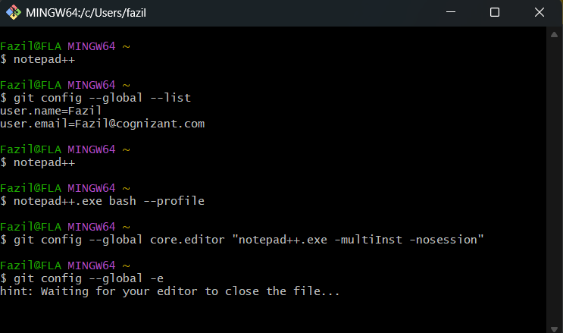

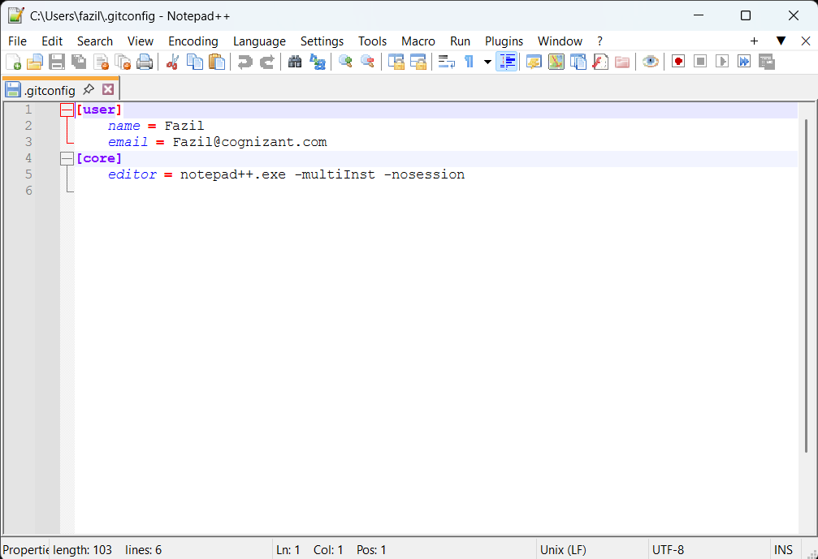

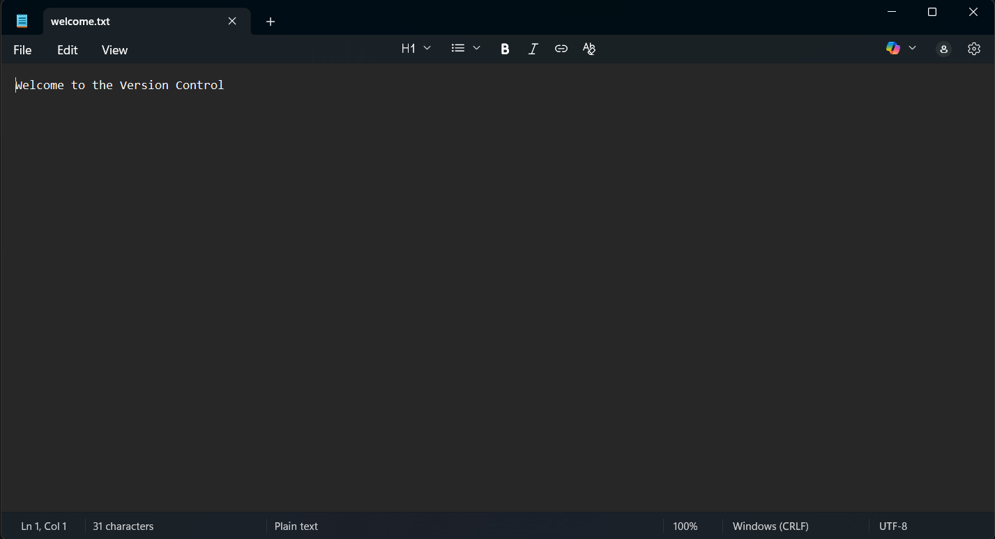

**Final Output:**

